DataStax ODBC driver with CQL connector for Apache Cassandra Installation Guide: -

The DataStax ODBC Driver for Apache Cassandra enables the integration with a broad array of tools for data processing, migration, analysis and visualization by leveraging the power of both CQL and SQL. It stands as a simple integration point to tap into the online data stored in Apache Cassandra, the massive, scale-out, always-on, distributed database that was built for the cloud, mobile, and internet-of-things.

Here are the steps of running DevCenter installation;

Step 1) First of all, you may take executable file from this location. \\ivl-srv1\VZ Soft\ DataStax ODBC driver.

Step 2) Next, let’s install the driver. DataStaxCassandraODBC64.msi: follow the below screen shot.

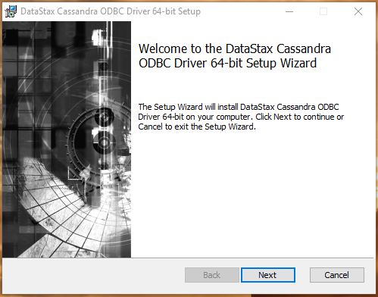

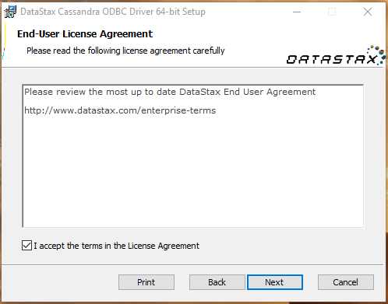

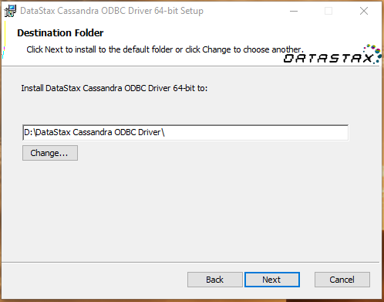

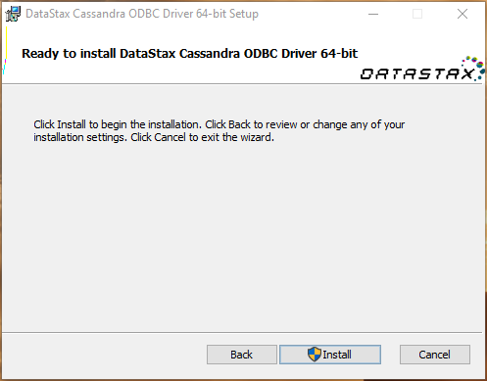

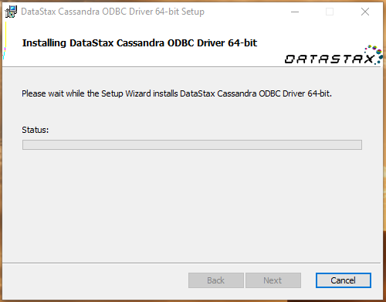

After installation will see a success screen:

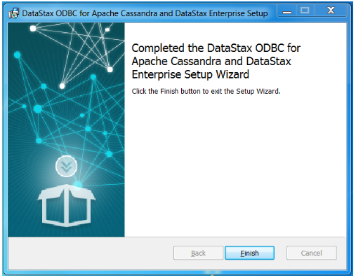

Now to set up a Data Source Name (DSN) for use in the ODBC tools.  Start by opening the ODBC Administrator.  You can find it under the Start menu, under the DataStax ODBC Driver for Apache Cassandra folder:

To create a DSN that only the user currently logged into Windows can use, click the “User DSN” tab.

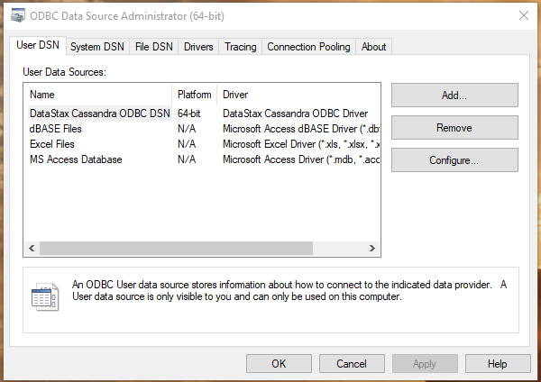

Click Add button.

In the Create New Data Source dialog box, select DataStax Cassandra ODBC Driver and then click Finish. The DataStax Cassandra ODBC Driver DSN Setup dialog box opens. In the Data Source Name field, type a name for your DSN. Optionally, in the Description field, type relevant details about the DSN. In the Host field, type the name(localhost) or IP address of the host where your Cassandra instance is running. Or, in the Host field, type a comma-separated list of host names or IP addresses of Cassandra servers to which the driver connects.

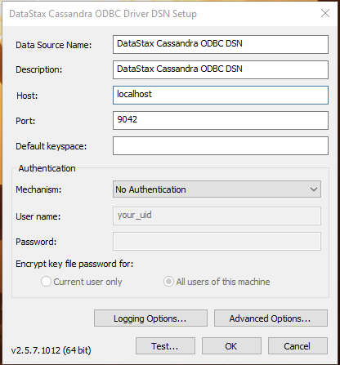

Click “Test…” button

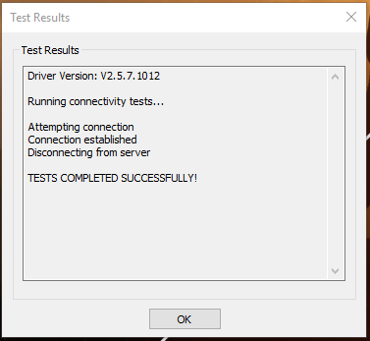

Click “OK”, then click “OK”, and finally click “OK” a third time.  Now you have configured a DSN, and you can use this DSN in your ODBC-based tools.

Use the “Tableau” and connect to a simple data set in Apache Cassandra to explore.

Step1) Installed Tableau version 8.3, you can take setup file form this location \\ivl-srv1\VZ Soft\ DataStax ODBC driver.

Step2) From here, click “Connect to data”:

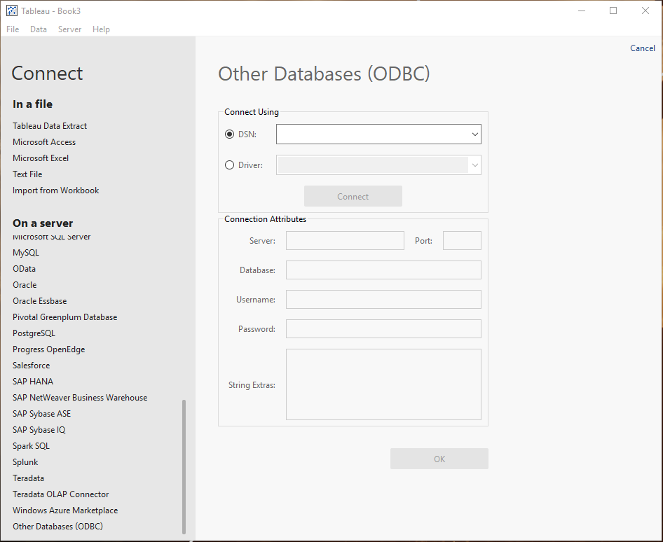

Step3) Select “Other Databases (ODBC)” and choose the DSN we created above.

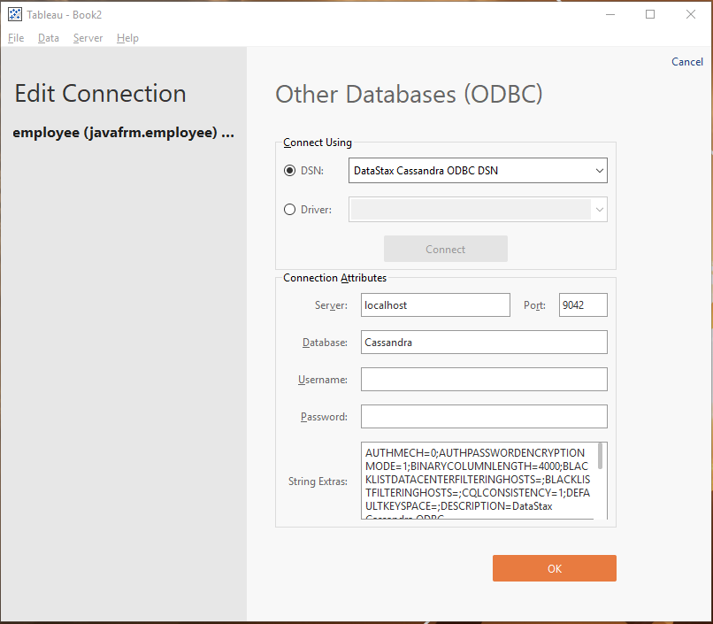

I used the default name “DataStax Cassandra ODBC DSN”. Next, click “Connect”, and fill out the Server, Port, and Database fields. For this example, we will use the javafrm keyspace which is included as a demo in Cassandra.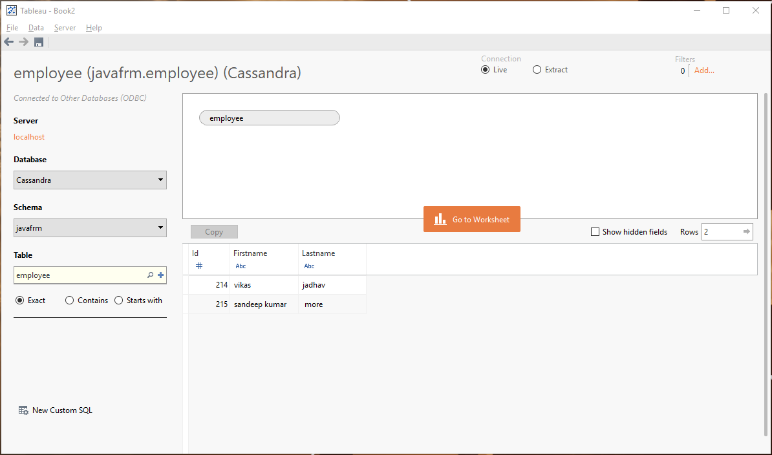

Important Note: - Tableau is paid software, I used as 14 days trail version. For more information regarding “Tableau”, kindly follow this url- <https://www.guru99.com/tableau-tutorial.html>

Thanks